**[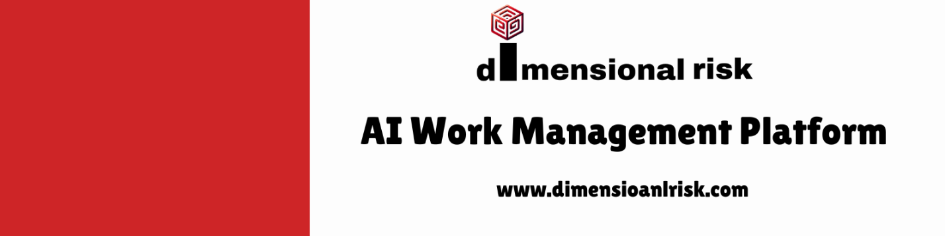](https://www.dimensionalrisk.com/)**

**Talent Review and Planning Survey**

Purpose:

This survey is designed to help evaluate the talent within the organization, identify key areas for improvement, and plan workforce needs, including succession planning and development opportunities.

**Section 1: Employee Performance**

How would you rate the overall performance of your direct reports over the past year?

☐ 1 – Poor

☐ 2 – Fair

☐ 3 – Good

☐ 4 – Very Good

☐ 5 – Excellent

Which employee(s) do you consider the highest performers in your team?

What are the key strengths of your top-performing employees?

Are there any employees who are underperforming or not meeting expectations?

☐ Yes

☐ No

If yes, please elaborate on the performance gaps:

**Section 2: Talent Development and Skills Gaps**

What key skills do you believe are currently lacking within your team?

How would you rate the training and development opportunities provided to your team members?

☐ 1 – Poor

☐ 2 – Fair

☐ 3 – Good

☐ 4 – Very Good

☐ 5 – Excellent

Do you feel your team has the necessary resources to excel in their roles?

☐ Yes

☐ No

If no, please explain:

Are there any employees you believe would benefit from additional training or mentorship to grow into leadership roles?

☐ Yes

☐ No

If yes, please provide details:

**Section 3: Succession Planning & Leadership Potential**

Do you have a clear succession plan for key roles within your team?

☐ Yes

☐ No

If no, what steps do you think are needed to develop one?

Which employees do you think show strong leadership potential for the next 1-3 years?

What steps do you think the organization should take to prepare high-potential employees for future leadership roles?

**Section 4: Workforce & Diversity Planning**

Do you foresee any significant changes in your team structure (e.g., new roles, reorganization) over the next year?

☐ Yes

☐ No

If yes, please provide details:

What is the current diversity profile of your team, and how does it compare to company-wide diversity goals?

Are there any diversity-related initiatives you believe should be prioritized within your team for the upcoming year?

**Section 5:Future Planning and Organizational Needs**

What is the most critical talent needs your team will face in the upcoming year?

Instructions for Completion:

This survey should be completed by each department manager/team lead.

Please be as specific as possible, particularly in the open-ended sections, to provide the HR team with actionable insights.

Responses will be kept confidential and are intended to guide talent management and workforce planning for the upcoming year.

Disclaimer:

Any articles, templates, or information provided by Dimensional Risk on the website are for reference only. While we strive to keep the information up to date and correct, we make no representations or warranties of any kind, express or implied, about the completeness, accuracy, reliability, suitability, or availability with respect to the website or the information, articles, templates, or related graphics contained on the website. Any reliance you place on such information is therefore strictly at your own risk.

[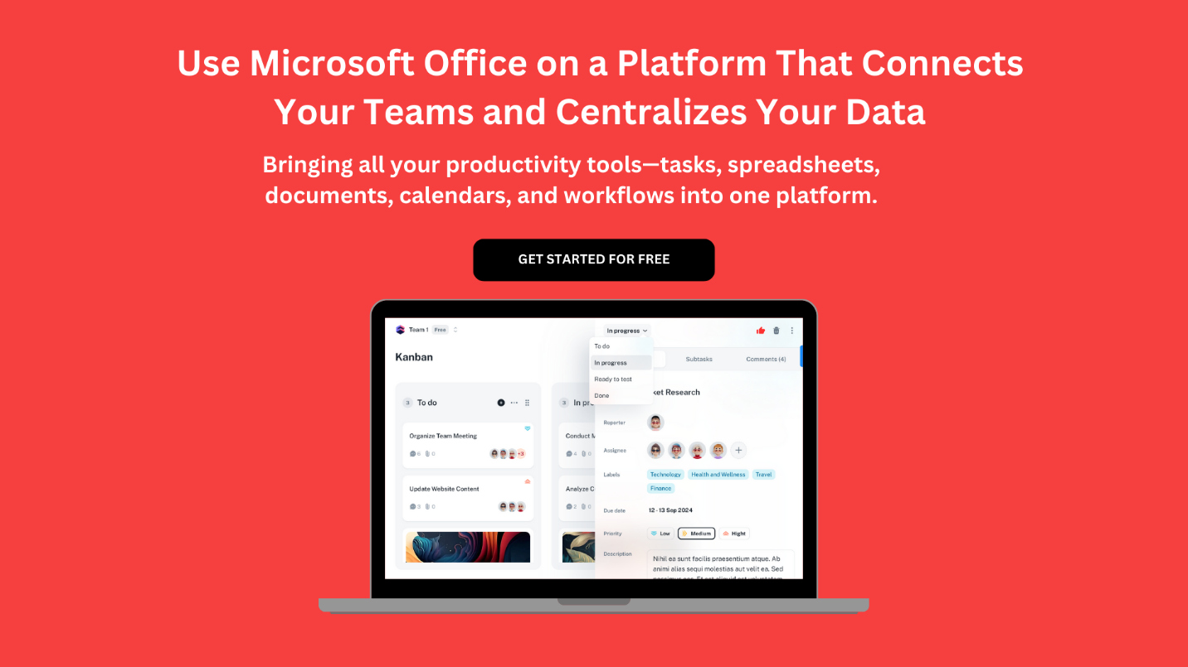](https://www.dimensionalrisk.com/)