**[](https://www.dimensionalrisk.com/)**

**Digital Marketing Strategy Assessment Survey**

**Purpose:**

This survey evaluates the effectiveness of the organization’s digital marketing strategies, including SEO, social media, paid advertising, and email marketing, to refine efforts for the new year.

**Overall Strategy**

1. **How effective was the overall digital marketing strategy in achieving business goals last year?**☐ Very Ineffective  
   ☐ Ineffective  
   ☐ Neutral  
   ☐ Effective  
   ☐ Very Effective
2. **Which digital marketing channels were most effective in driving results?**☐ Social Media  
   ☐ SEO/Organic Search  
   ☐ Paid Advertising (PPC)  
   ☐ Email Marketing  
   ☐ Content Marketing  
   ☐ Other
3. **Which channels underperformed, and what were the key challenges?**

**Website and SEO**

1. **How effective was the website in converting visitors into leads or customers?**☐ Very Ineffective  
   ☐ Ineffective  
   ☐ Neutral  
   ☐ Effective  
   ☐ Very Effective
2. **Were SEO efforts successful in improving organic search rankings and traffic?**☐ Yes  
   ☐ No  
   ☐ Somewhat
3. **What areas of the website or SEO strategy need improvement?**

**Social Media**

1. **Which social media platforms were most successful in engaging the target audience?**☐ Facebook  
   ☐ Instagram  
   ☐ LinkedIn  
   ☐ Twitter/X  
   ☐ TikTok  
   ☐ Other
2. **How consistent and engaging was the content shared on social media?**☐ Very Poor  
   ☐ Poor  
   ☐ Neutral  
   ☐ Good  
   ☐ Excellent
3. **What additional steps could be taken to improve social media engagement?**

**Paid Advertising**

1. **How effective were paid advertising campaigns (e.g., Google Ads, social media ads) in achieving ROI?**☐ Very Ineffective  
   ☐ Ineffective  
   ☐ Neutral  
   ☐ Effective  
   ☐ Very Effective
2. **Were the ad budgets allocated effectively across platforms?**☐ Yes  
   ☐ No  
   ☐ Somewhat
3. **What optimizations are needed for paid advertising campaigns this year?**

**Email Marketing and Content**

1. **How effective were email marketing campaigns in driving engagement and conversions?**☐ Very Ineffective  
   ☐ Ineffective  
   ☐ Neutral  
   ☐ Effective  
   ☐ Very Effective
2. **What types of content performed best in attracting and retaining customers?**☐ Blogs  
   ☐ Videos  
   ☐ Infographics  
   ☐ Case Studies  
   ☐ Whitepapers  
   ☐ Other
3. **What new content formats or topics should the marketing team explore this year?**

**Future Planning**

1. **What are the top three priorities for digital marketing in the upcoming year?**
2. **Are there any tools or resources needed to improve digital marketing performance?**☐ Yes  
   ☐ No **If yes, please specify:**
3. **What trends or innovations should the digital marketing team focus on this year?**
4. **What challenges or obstacles might impact digital marketing success this year?**
5. **Is there anything else you’d like to share about the digital marketing strategy?**

**Instructions for Completion:**

* This survey is intended for marketing teams, digital strategists, and stakeholders involved in digital marketing efforts.
* Please provide detailed feedback to refine strategies and optimize digital marketing efforts for the year ahead.

Disclaimer:

Any articles, templates, or information provided by Dimensional Risk on the website are for reference only. While we strive to keep the information up to date and correct, we make no representations or warranties of any kind, express or implied, about the completeness, accuracy, reliability, suitability, or availability with respect to the website or the information, articles, templates, or related graphics contained on the website. Any reliance you place on such information is therefore strictly at your own risk.

[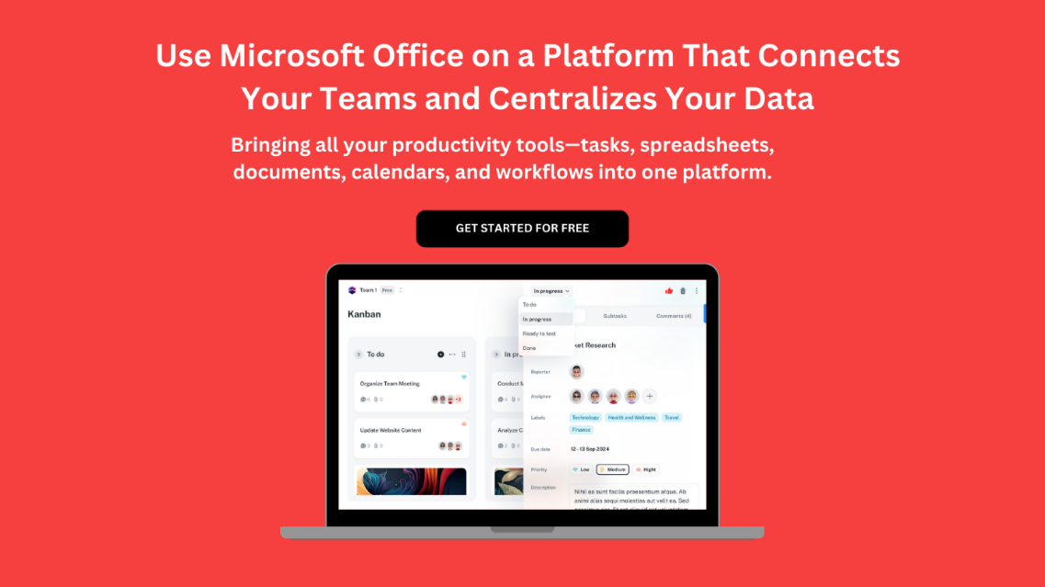](https://www.dimensionalrisk.com/)