**[](https://www.dimensionalrisk.com/)**

**Diversity & Inclusion Survey**

**Purpose:**

This survey aims to assess how inclusive the workplace is, gather feedback on diversity-related initiatives, and identify opportunities to improve equity and belonging within the organization.

**Workplace Inclusivity**

1. **Do you feel the company values diversity and inclusivity?**  
   ☐ Strongly Disagree  
   ☐ Disagree  
   ☐ Neutral  
   ☐ Agree  
   ☐ Strongly Agree
2. **Do you feel respected and valued at work regardless of your background, identity, or beliefs?**  
   ☐ Strongly Disagree  
   ☐ Disagree  
   ☐ Neutral  
   ☐ Agree  
   ☐ Strongly Agree
3. **Do you believe all employees have equal opportunities for growth and advancement within the company?**  
   ☐ Yes  
   ☐ No  
   ☐ Not Sure

**Perceptions of Diversity**

1. **How diverse do you feel your team is in terms of background, skills, and experiences?**  
   ☐ Not Diverse  
   ☐ Somewhat Diverse  
   ☐ Neutral  
   ☐ Diverse  
   ☐ Very Diverse
2. **Do you believe the organization is actively working to improve diversity in hiring practices?**  
   ☐ Yes  
   ☐ No  
   ☐ Not Sure
3. **Do you see diversity represented in leadership roles across the organization?**  
   ☐ Yes  
   ☐ No  
   ☐ Somewhat

**Inclusion Practices**

1. **Do you feel included in decision-making processes and team discussions?**  
   ☐ Yes  
   ☐ No  
   ☐ Sometimes
2. **Have you experienced or witnessed any form of bias or discrimination in the workplace?**  
   ☐ Yes  
   ☐ No  
   If yes, please elaborate:  
   ☐ [Open-ended field]
3. **Do you feel comfortable voicing your opinions or concerns without fear of retaliation?**  
   ☐ Yes  
   ☐ No  
   ☐ Sometimes

**Training and Education**

1. **Have you participated in any diversity and inclusion training provided by the company?**  
   ☐ Yes  
   ☐ No
2. **Do you feel the training sessions have positively influenced workplace culture?**  
   ☐ Strongly Disagree  
   ☐ Disagree  
   ☐ Neutral  
   ☐ Agree  
   ☐ Strongly Agree
3. **What additional resources or programs would help the company improve inclusivity?**

**Overall Perception and Suggestions**

1. **On a scale of 1-10, how inclusive do you feel the company culture is?**  
   ☐ 1 (Not Inclusive)  
   ☐ 2  
   ☐ 3  
   ☐ 4  
   ☐ 5  
   ☐ 6  
   ☐ 7  
   ☐ 8  
   ☐ 9  
   ☐ 10 (Very Inclusive)
2. **What changes or initiatives would you recommend to improve diversity and inclusion at the company?**
3. **Is there anything else you would like to share about your experience with diversity and inclusion in the workplace?**

**Instructions for Completion:**

* This survey is anonymous and intended for all employees.
* Your feedback is critical to improving our diversity and inclusion initiatives.
* Please answer as honestly as possible to help us create a more inclusive and equitable workplace.

gather insights about employee satisfaction, engagement, and the overall work environment to help the organization enhance workplace culture and improve retention.

[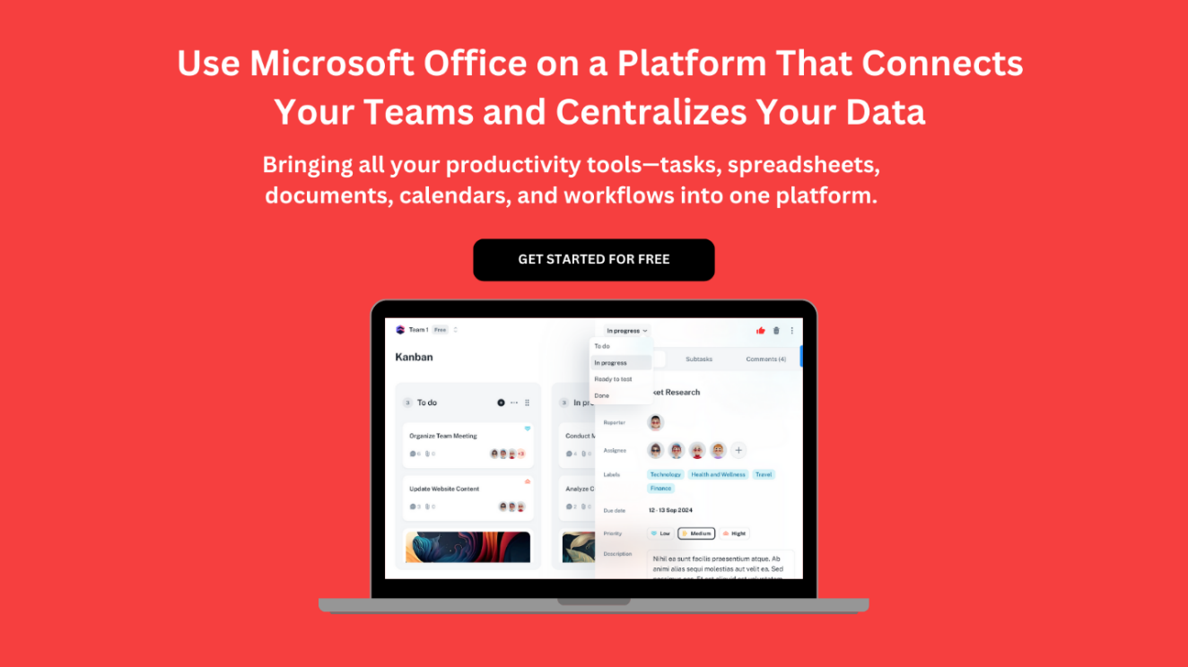](https://www.dimensionalrisk.com/)