**[](https://www.dimensionalrisk.com/)**

**Client Satisfaction & Project Feedback Survey**

**Purpose:**

This survey evaluates client satisfaction with past consulting engagements, measures the effectiveness of consulting solutions, and gathers feedback to improve future projects..

**Overall Satisfaction**

1. **How satisfied are you with the consulting services provided by our firm?**☐ Very Dissatisfied  
   ☐ Dissatisfied  
   ☐ Neutral  
   ☐ Satisfied  
   ☐ Very Satisfied
2. **Did our team meet your expectations for the project?**☐ Yes  
   ☐ No **If no, please specify what fell short:**
3. **How likely are you to recommend our consulting services to others?**☐ 1 (Not Likely)  
   ☐ 2  
   ☐ 3  
   ☐ 4  
   ☐ 5  
   ☐ 6  
   ☐ 7  
   ☐ 8  
   ☐ 9  
   ☐ 10 (Very Likely)

**Project Execution**

1. **How would you rate the quality of the solutions provided during the project?**☐ Very Poor  
   ☐ Poor  
   ☐ Neutral  
   ☐ Good  
   ☐ Excellent
2. **Was the project delivered on time and within budget?**☐ Yes  
   ☐ No **If no, please describe the challenges:**
3. **How effectively did the consulting team communicate and collaborate with your team?**☐ Very Poorly  
   ☐ Poorly  
   ☐ Neutral  
   ☐ Well  
   ☐ Very Well

**Impact and Results**

1. **Did the consulting solutions address the specific challenges or goals outlined at the start of the project?**☐ Yes  
   ☐ No **If no, please specify what was missing:**
2. **How satisfied are you with the measurable outcomes of the project (e.g., ROI, operational improvements)?**☐ Very Dissatisfied  
   ☐ Dissatisfied  
   ☐ Neutral  
   ☐ Satisfied  
   ☐ Very Satisfied
3. **What specific impact did the consulting project have on your organization?**

**Consulting Team**

1. **How would you rate the expertise and professionalism of the consulting team?**☐ Very Poor  
   ☐ Poor  
   ☐ Neutral  
   ☐ Good  
   ☐ Excellent
2. **Were you satisfied with the level of engagement and responsiveness from the consulting team?**☐ Yes  
   ☐ No **If no, please describe:**
3. **Was the consulting team able to adapt to changes in project scope or priorities?  
   ☐ Yes  
   ☐ No**

**Improvement Opportunities**

1. **What could we have done differently to improve your experience with the project?**
2. **Are there additional services or solutions you would like us to offer in future engagements?**☐ Yes  
   ☐ No **If yes, please specify:**
3. **Is there anything else you would like to share about your experience with our consulting services?**

**Instructions for Completion:**

* This survey is intended for clients who have engaged with the consulting firm on recent projects.
* Please provide honest feedback to help improve consulting services and solutions.
* Your input will guide enhancements to project delivery, communication, and service offerings.

Disclaimer:

Any articles, templates, or information provided by Dimensional Risk on the website are for reference only. While we strive to keep the information up to date and correct, we make no representations or warranties of any kind, express or implied, about the completeness, accuracy, reliability, suitability, or availability with respect to the website or the information, articles, templates, or related graphics contained on the website. Any reliance you place on such information is therefore strictly at your own risk.

[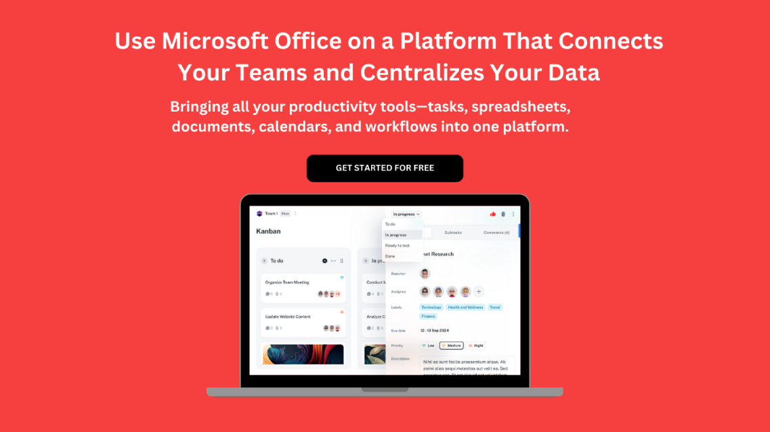](https://www.dimensionalrisk.com/)