**[](https://www.dimensionalrisk.com/)**

**Consulting Performance & Strategy Assessment Survey**

**Purpose:**This survey evaluates the consulting firm’s performance, methodologies, and strategic approach to delivering value to clients, ensuring continuous improvement for the year ahead.

**Strategic Alignment**

1. **How well do our consulting services align with your organization’s strategic goals?**☐ Very Poorly  
   ☐ Poorly  
   ☐ Neutral  
   ☐ Well  
   ☐ Very Well
2. **Were the strategies recommended by our team actionable and relevant to your business challenges?**☐ Strongly Disagree  
   ☐ Disagree  
   ☐ Neutral  
   ☐ Agree  
   ☐ Strongly Agree
3. **How effective were the proposed solutions in delivering measurable outcomes?**☐ Very Ineffective  
   ☐ Ineffective  
   ☐ Neutral  
   ☐ Effective  
   ☐ Very Effective

**Methodologies and Tools**

1. **How would you rate the consulting methodologies used during the project?**☐ Very Poor  
   ☐ Poor  
   ☐ Neutral  
   ☐ Good  
   ☐ Excellent
2. **Were the tools and frameworks provided by the consulting team effective in solving your challenges?**☐ Yes  
   ☐ No  
   ☐ Somewhat
3. **Are there any additional tools or methodologies you think we should incorporate into our services?**☐ Yes  
   ☐ No  
   If yes, please describe:

**Communication and Collaboration**

1. **How would you rate the communication between your team and the consulting team throughout the engagement?**☐ Very Poor  
   ☐ Poor  
   ☐ Neutral  
   ☐ Good  
   ☐ Excellent
2. **Did the consulting team collaborate effectively with your stakeholders?**☐ Yes  
   ☐ No  
   ☐ Somewhat
3. **What could we have done to improve communication and collaboration during the project?**

**Value Delivery**

1. **Did the project deliver the expected value for the investment made?**☐ Yes  
   ☐ No  
   If no, please describe:
2. **What specific results or improvements did you see as a result of the consulting project?**
3. **How likely are you to engage our consulting services for future projects?**☐ Very Unlikely  
   ☐ Unlikely  
   ☐ Neutral  
   ☐ Likely  
   ☐ Very Likely

**Improvement Opportunities**

1. **What could we have done differently to improve the overall experience and outcomes of the project?**
2. **Are there additional services or areas of expertise you would like us to offer?  
   ☐ Yes  
   ☐ No  
   If yes, please specify:**
3. **Is there anything else you would like to share about our consulting performance or strategies?**

**Instructions for Completion:**

* This survey is intended for clients and internal stakeholders to provide feedback on the performance and strategies of the consulting team.
* Please provide honest feedback to help the firm refine its methodologies and approach.
* Responses will guide improvements to consulting delivery and strategic alignment for the upcoming year.

Disclaimer:

Any articles, templates, or information provided by Dimensional Risk on the website are for reference only. While we strive to keep the information up to date and correct, we make no representations or warranties of any kind, express or implied, about the completeness, accuracy, reliability, suitability, or availability with respect to the website or the information, articles, templates, or related graphics contained on the website. Any reliance you place on such information is therefore strictly at your own risk.

[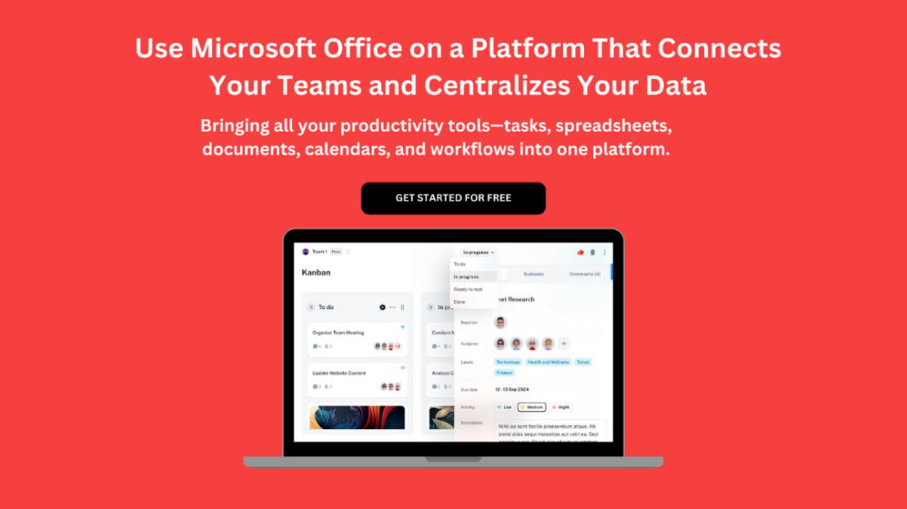](https://www.dimensionalrisk.com/)