**[](https://www.dimensionalrisk.com/)**

**Enterprise Risk Assessment Survey**

**Purpose:**This survey evaluates the organization’s exposure to various risks, helping prioritize risk mitigation strategies for the year ahead.

**Risk Identification**

1. **What are the top three risks facing the organization this year?**
2. **How confident are you that all key risks have been identified?**☐ Not Confident  
   ☐ Slightly Confident  
   ☐ Neutral  
   ☐ Confident  
   ☐ Very Confident
3. **Are there any new or emerging risks that the organization should monitor?**☐ Yes  
   ☐ No **If yes, please describe:**

**Risk Categories**

1. **Which of the following categories pose the highest risk to the organization this year? (Select all that apply)**☐ Financial Risk  
   ☐ Operational Risk  
   ☐ Cybersecurity Risk  
   ☐ Compliance Risk  
   ☐ Strategic Risk  
   ☐ Reputational Risk  
   ☐ Other
2. **Which areas of the business are most vulnerable to risks this year?**
3. **How likely is it that external factors (e.g., economic downturns, regulatory changes) will impact the organization’s risk profile this year?**☐ Very Unlikely  
   ☐ Unlikely  
   ☐ Neutral  
   ☐ Likely  
   ☐ Very Likely

**Risk Mitigation**

1. **Does the organization have adequate resources to mitigate identified risks?**☐ Yes  
   ☐ No  
   ☐ Somewhat
2. **How effective are the current risk mitigation strategies in reducing exposure to key risks?**☐ Very Ineffective  
   ☐ Ineffective  
   ☐ Neutral  
   ☐ Effective  
   ☐ Very Effective
3. **Are there any specific risks that require immediate attention or escalation?**☐ Yes  
   ☐ No **If yes, please specify:**

**Risk Monitoring and Reporting**

1. **Does the organization have a system for tracking and monitoring risks throughout the year?**☐ Yes  
   ☐ No  
   ☐ In Progress
2. **How frequently are risks reviewed and updated?**☐ Monthly  
   ☐ Quarterly  
   ☐ Annually  
   ☐ Rarely
3. **How effective is the organization’s risk reporting process in providing actionable insights to leadership?**☐ Very Ineffective  
   ☐ Ineffective  
   ☐ Neutral  
   ☐ Effective  
   ☐ Very Effective

**Future Planning**

1. **What additional resources or tools would help improve risk management processes?**
2. **What steps should the organization take to improve its risk management framework this year?**
3. **Is there anything else you would like to share about the organization’s risk management practices?**

**Instructions for Completion:**

* This survey is intended for risk managers, department heads, and leadership teams involved in enterprise risk management.
* Please provide detailed feedback to help prioritize and address the most critical risks facing the organization.
* Responses will guide updates to the risk management framework and mitigation strategies

Disclaimer:

Any articles, templates, or information provided by Dimensional Risk on the website are for reference only. While we strive to keep the information up to date and correct, we make no representations or warranties of any kind, express or implied, about the completeness, accuracy, reliability, suitability, or availability with respect to the website or the information, articles, templates, or related graphics contained on the website. Any reliance you place on such information is therefore strictly at your own risk.

[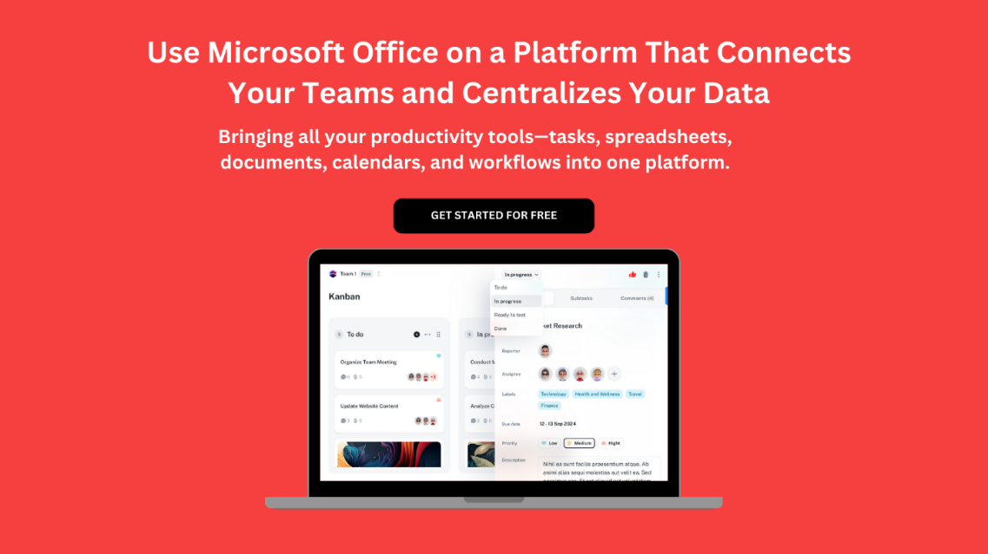](https://www.dimensionalrisk.com/)