**[](https://www.dimensionalrisk.com/)**

**Annual Marketing Performance Review Survey**

**Purpose:**

This survey assesses the success of last year’s marketing campaigns, channels, and strategies to identify areas for improvement and opportunities for growth in the upcoming year.

**Campaign Performance**

1. **How effective were last year’s marketing campaigns in achieving their goals?**☐ Very Ineffective  
   ☐ Ineffective  
   ☐ Neutral  
   ☐ Effective  
   ☐ Very Effective
2. **Which campaign performed the best last year, and why?**
3. **Which campaign underperformed, and what were the key challenges?**

**Channel Effectiveness**

1. **Which marketing channels were the most effective in driving ROI?**☐ Social Media  
   ☐ Email Marketing  
   ☐ Paid Advertising (PPC)  
   ☐ SEO/Organic Search  
   ☐ Events/Conferences  
   ☐ Other: [Specify in open-ended field]
2. **Which marketing channels require additional focus or optimization this year?**
3. **How would you rate the effectiveness of the tools and platforms used for marketing campaigns?**☐ Very Ineffective  
   ☐ Ineffective  
   ☐ Neutral  
   ☐ Effective  
   ☐ Very Effective

**Audience Engagement**

1. **How well did the marketing efforts resonate with the target audience last year?**☐ Very Poorly  
   ☐ Poorly  
   ☐ Neutral  
   ☐ Well  
   ☐ Very Well
2. **Were there any significant changes in customer behavior or preferences that impacted marketing performance?  
   ☐ Yes  
   ☐ No  
   If yes, please describe:**
3. **What additional steps can be taken to better engage the target audience this year?**

**Team and Budget**

1. **Was the marketing budget sufficient to meet objectives last year?  
   ☐ Yes  
   ☐ No  
   ☐ Somewhat**
2. **Were there any resource gaps (e.g., personnel, technology) that hindered marketing success?  
   ☐ Yes  
   ☐ No  
   If yes, please specify:**
3. **How well did the marketing team collaborate with other departments (e.g., sales, product) to achieve goals?  
   ☐ Very Poorly  
   ☐ Poorly  
   ☐ Neutral  
   ☐ Well  
   ☐ Very Well**

**Future Planning**

1. **What are the top three marketing priorities for the upcoming year?  
   ☐ [Open-ended field]**
2. **Are there any new trends or opportunities that the marketing team should explore this year?  
   ☐ [Open-ended field]**
3. **Is there anything else you would like to share about the organization’s marketing performance and strategies?**

**Instructions for Completion:**

* This survey is intended for marketing teams, department heads, and leadership involved in marketing strategy and performance evaluation.
* Please provide detailed feedback to help refine and improve marketing efforts for the upcoming year.
* Responses will guide the allocation of resources, adjustments to strategies, and exploration of new opportunities.

Disclaimer:

Any articles, templates, or information provided by Dimensional Risk on the website are for reference only. While we strive to keep the information up to date and correct, we make no representations or warranties of any kind, express or implied, about the completeness, accuracy, reliability, suitability, or availability with respect to the website or the information, articles, templates, or related graphics contained on the website. Any reliance you place on such information is therefore strictly at your own risk.

[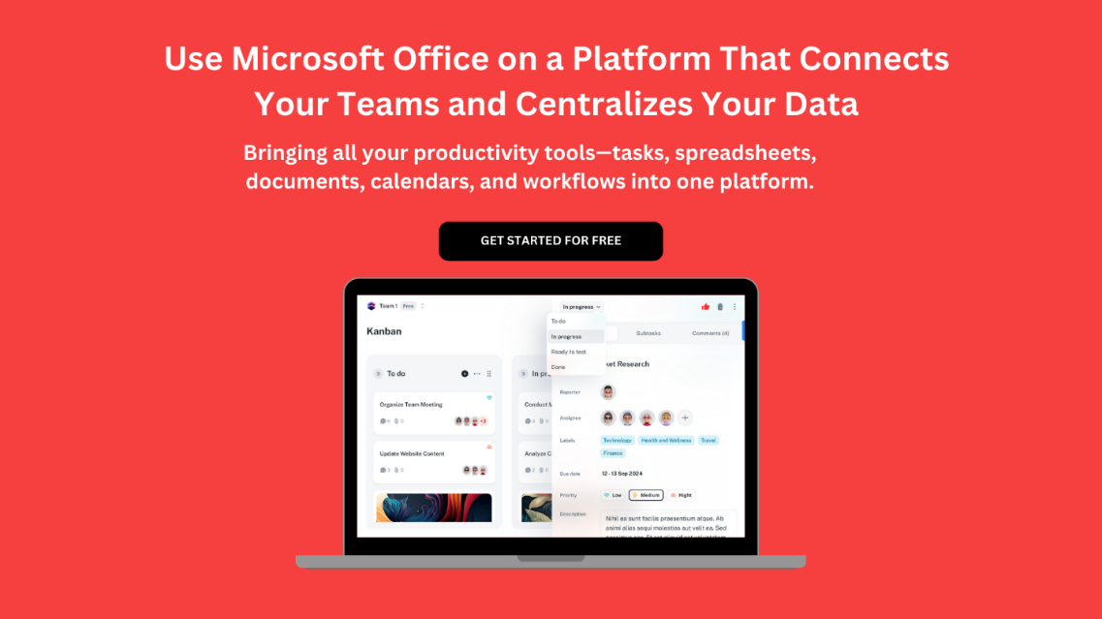](https://www.dimensionalrisk.com/)