**[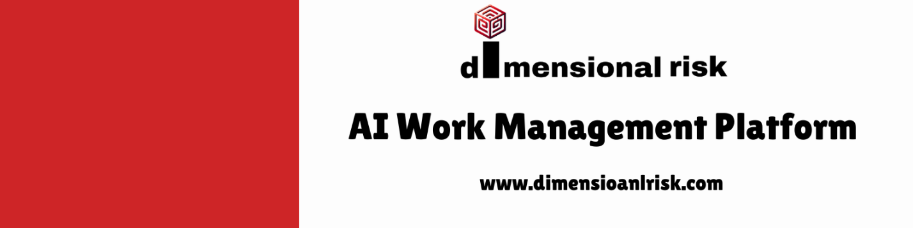](https://www.dimensionalrisk.com/)**

**Market & Industry Trends Survey**

**Purpose:**This survey evaluates the consulting firm’s awareness and alignment with market trends, client needs, and emerging opportunities to remain competitive and provide valuable insights to clients.

**Industry Awareness**

1. **How well does the firm understand current trends and challenges in your industry?**  
   ☐ Very Poorly  
   ☐ Poorly  
   ☐ Neutral  
   ☐ Well  
   ☐ Very Well
2. **Are there any emerging trends in your industry that you feel the firm should focus on this year?**  
   ☐ Yes  
   ☐ No  
   If yes, please describe:  
   ☐ [Open-ended field]
3. **How would you rate the firm’s ability to provide innovative solutions aligned with industry trends?**  
   ☐ Very Poor  
   ☐ Poor  
   ☐ Neutral  
   ☐ Good  
   ☐ Excellent

**Competitive Positioning**

1. **How does our firm compare to competitors in terms of understanding market trends and client needs?**  
   ☐ Significantly Worse  
   ☐ Worse  
   ☐ Neutral  
   ☐ Better  
   ☐ Significantly Better
2. **What differentiates our consulting firm from competitors?**  
   ☐ [Open-ended field]
3. **Are there any services or solutions you feel our firm is lacking compared to competitors?**  
   ☐ Yes  
   ☐ No  
   If yes, please describe:

**Client Needs**

1. **How well do our current services align with your organization’s needs and priorities?**  
   ☐ Very Poorly  
   ☐ Poorly  
   ☐ Neutral  
   ☐ Well  
   ☐ Very Well
2. **Are there any specific challenges or opportunities you foresee for your organization this year that require consulting support?**  
   ☐ Yes  
   ☐ No  
   If yes, please specify:
3. **How likely are you to engage our firm for additional services based on current industry needs?**  
   ☐ Very Unlikely  
   ☐ Unlikely  
   ☐ Neutral  
   ☐ Likely  
   ☐ Very Likely

**Adapting to Change**

1. **How well does the firm adapt its services to respond to changes in market conditions or industry demands?**  
   ☐ Very Poorly  
   ☐ Poorly  
   ☐ Neutral  
   ☐ Well  
   ☐ Very Well
2. **What areas of improvement would you recommend for the firm to stay ahead of industry changes?**
3. **Do you feel the firm is adequately prepared to address emerging challenges in your industry?**  
   ☐ Yes  
   ☐ No  
   ☐ Somewhat

**Future Opportunities**

1. **What trends or innovations should the firm explore to add more value to its consulting services?**
2. **Are there any untapped opportunities in your industry that you think the firm should pursue?**  
   ☐ Yes  
   ☐ No  
   If yes, please specify:
3. **Is there anything else you would like to share about the firm’s approach to market and industry trends?**

**Instructions for Completion:**

* This survey is intended for clients, industry experts, and internal stakeholders to provide insights into market trends and consulting needs.
* Please provide detailed feedback to help the firm refine its services and align with emerging opportunities.
* Responses will guide the development of innovative solutions and strategic priorities for the year.

Disclaimer:

Any articles, templates, or information provided by Dimensional Risk on the website are for reference only. While we strive to keep the information up to date and correct, we make no representations or warranties of any kind, express or implied, about the completeness, accuracy, reliability, suitability, or availability with respect to the website or the information, articles, templates, or related graphics contained on the website. Any reliance you place on such information is therefore strictly at your own risk.

[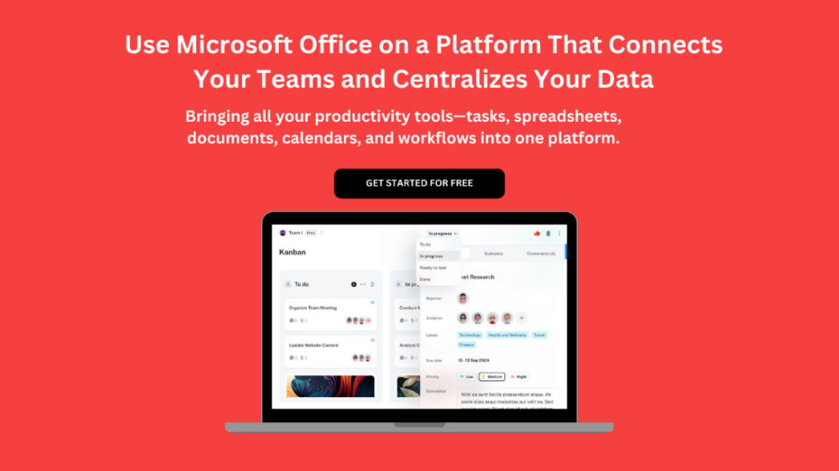](https://www.dimensionalrisk.com/)