**[](https://www.dimensionalrisk.com/)**

**Legal Compliance Readiness Survey**

**Purpose:**

This survey assesses the organization's readiness to meet legal and regulatory requirements for the upcoming year. It helps identify gaps, align priorities, and ensure compliance processes are on track.

**Compliance Framework**

1. **Are all legal and compliance policies updated to reflect the latest regulations for this year?  
   ☐** Yes  
   ☐ No  
   ☐ Not Sure
2. **Have key changes in regulations relevant to the business been identified and communicated to the necessary teams?  
   ☐** Yes  
   ☐ No  
   ☐ In Progress
3. **How would you rate the organization’s overall compliance framework at the start of this year?  
   ☐** Very Poor  
   ☐ Poor  
   ☐ Neutral  
   ☐ Good  
   ☐ Excellent

**Audit Readiness**

1. **Is the organization prepared for internal or external audits scheduled for this year?  
   ☐** Yes  
   ☐ No  
   ☐ Not Sure
2. **Have all necessary compliance documents and records been reviewed and organized for audits?**☐ Yes  
   ☐ No  
   ☐ In Progress
3. **Are all departments aware of their roles and responsibilities in ensuring audit readiness?  
   ☐** Yes  
   ☐ No  
   ☐ Somewhat

**Training and Awareness**

1. **Have employees been trained on compliance protocols for the upcoming year?**☐ Yes  
   ☐ No  
   ☐ Training Scheduled
2. **How effective is the compliance training provided to employees?  
   ☐** Very Ineffective  
   ☐ Ineffective  
   ☐ Neutral  
   ☐ Effective  
   ☐ Very Effective
3. **Do employees have access to resources to understand and adhere to new legal requirements?  
   ☐** Yes  
   ☐ No  
   ☐ Not Sure

**Risk Assessment and Mitigation**

1. **Have potential compliance risks for this year been identified and documented?**☐ Yes  
   ☐ No  
   ☐ In Progress
2. **How confident are you in the organization’s ability to mitigate compliance risks this year?  
   ☐** Not Confident  
   ☐ Slightly Confident  
   ☐ Neutral  
   ☐ Confident  
   ☐ Very Confident
3. **Are there any specific compliance risks that require immediate attention?  
   ☐ Yes  
   ☐ No  
   If yes, please describe:**

**Planning and Improvement**

1. **What are the key compliance priorities for your department this year?**
2. **Are there any gaps in resources or support for meeting compliance requirements?**☐ Yes  
   ☐ No  
   **If yes, please specify:**
3. **What additional steps should the organization take to ensure compliance readiness for this year?**

**Instructions for Completion:**

* This survey should be completed by department heads, compliance officers, or team leads.
* Responses will help identify areas requiring attention and guide the organization in preparing for audits, regulatory updates, and compliance risks.
* Please provide as much detail as possible, especially in open-ended fields, to assist in addressing gaps effectively**.**

Disclaimer:

Any articles, templates, or information provided by Dimensional Risk on the website are for reference only. While we strive to keep the information up to date and correct, we make no representations or warranties of any kind, express or implied, about the completeness, accuracy, reliability, suitability, or availability with respect to the website or the information, articles, templates, or related graphics contained on the website. Any reliance you place on such information is therefore strictly at your own risk.

[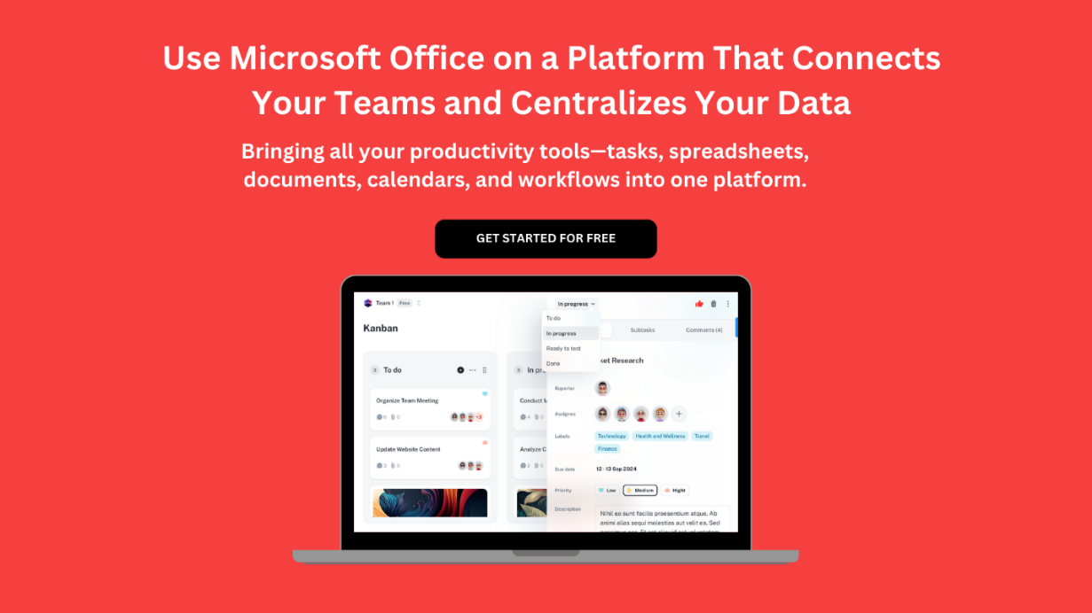](https://www.dimensionalrisk.com/)