**[](https://www.dimensionalrisk.com/)**

**Customer Satisfaction & Brand Perception Survey**

**Purpose:**

This survey gathers feedback from customers to evaluate their satisfaction with the organization’s products or services and understand how they perceive the brand.

**Customer Satisfaction**

1. **How satisfied are you with the overall quality of our products/services?**☐ Very Dissatisfied  
   ☐ Dissatisfied  
   ☐ Neutral  
   ☐ Satisfied  
   ☐ Very Satisfied
2. **How satisfied are you with the customer service you’ve received from our company?**☐ Very Dissatisfied  
   ☐ Dissatisfied  
   ☐ Neutral  
   ☐ Satisfied  
   ☐ Very Satisfied
3. **Have our products/services met your expectations?**☐ Yes  
   ☐ No **If no, please describe what fell short:**

**Customer Loyalty**

1. **How likely are you to recommend our company to a friend or colleague?**☐ 1 (Not Likely)  
   ☐ 2  
   ☐ 3  
   ☐ 4  
   ☐ 5  
   ☐ 6  
   ☐ 7  
   ☐ 8  
   ☐ 9  
   ☐ 10 (Very Likely)
2. **How likely are you to continue using our products/services in the future?**☐ Very Unlikely  
   ☐ Unlikely  
   ☐ Neutral  
   ☐ Likely  
   ☐ Very Likely

**Brand Perception**

1. **How would you describe your overall perception of our brand?**☐ Very Negative  
   ☐ Negative  
   ☐ Neutral  
   ☐ Positive  
   ☐ Very Positive
2. **What three words come to mind when you think of our brand?**
3. **Do you feel our brand stands out compared to competitors?**☐ Yes  
   ☐ No  
   ☐ Somewhat **If no, please explain:**

**Customer Engagement**

1. **How often do you interact with our company through the following channels?**
   * Social media: ☐ Never ☐ Rarely ☐ Sometimes ☐ Often ☐ Always
   * Email Marketing: ☐ Never ☐ Rarely ☐ Sometimes ☐ Often ☐ Always
   * Website: ☐ Never ☐ Rarely ☐ Sometimes ☐ Often ☐ Always
2. **What additional engagement or communication would you like from our company?**

**Improvement Opportunities**

1. **What do you think we could do to improve your experience with our company?**
2. **Are there any products, features, or services you’d like us to offer?**
3. **Have you faced any challenges or issues with our products/services?**☐ Yes  
   ☐ No **If yes, please describe:**

**Future Expectations**

1. **What trends or innovations do you think our company should explore?**
2. **Is there anything else you’d like to share about your experience with our brand?**

**Instructions for Completion:**

* This survey is intended for customers and clients to provide feedback about their experiences with the brand.
* Responses will help the marketing team identify areas for improvement, refine strategies, and enhance customer satisfaction.

Disclaimer:

Any articles, templates, or information provided by Dimensional Risk on the website are for reference only. While we strive to keep the information up to date and correct, we make no representations or warranties of any kind, express or implied, about the completeness, accuracy, reliability, suitability, or availability with respect to the website or the information, articles, templates, or related graphics contained on the website. Any reliance you place on such information is therefore strictly at your own risk.

[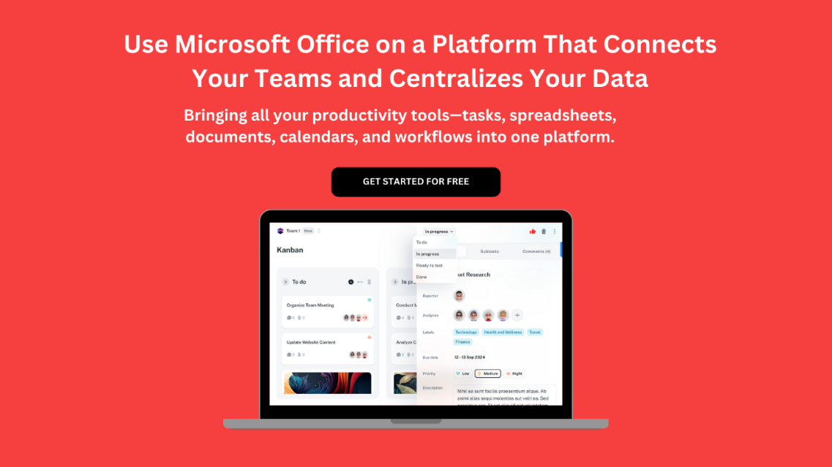](https://www.dimensionalrisk.com/)