**[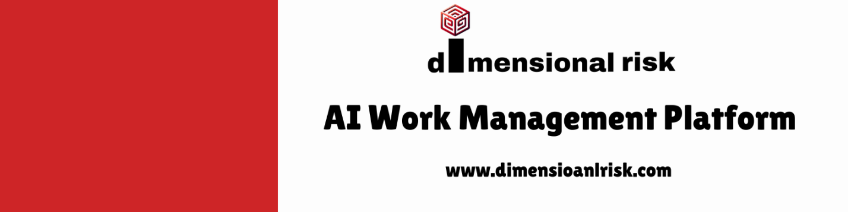](https://www.dimensionalrisk.com/)**

**Contract Review and Management Survey**

**Purpose:**

This survey evaluates the organization’s contract management processes, identifies gaps in compliance, and ensures all contracts are up-to-date and aligned with current regulations and business goals.

**Contract Inventory**

1. **Are all active contracts reviewed and updated for the new year?  
   ☐** Yes  
   ☐ No  
   ☐ In Progress
2. **Do you have a clear inventory of all active contracts within your department?  
   ☐** Yes  
   ☐ No  
   ☐ Partially
3. **How confident are you that no critical contracts are missing from the inventory?  
   ☐** Not Confident  
   ☐ Slightly Confident  
   ☐ Neutral  
   ☐ Confident  
   ☐ Very Confident

**Contract Compliance**

1. **Have all contracts been reviewed for compliance with current legal and regulatory requirements?  
   ☐ Yes  
   ☐ No  
   ☐ In Progress**
2. **Are there any contracts that require immediate renegotiation due to legal or business changes?  
   ☐** Yes  
   ☐ No  
   **If yes, please list the contracts:**
3. **Do all contracts include clear terms and conditions regarding liability, confidentiality, and dispute resolution?  
   ☐** Yes  
   ☐ No  
   ☐ Not Sure

**Contract Management Process**

1. **How would you rate the current process for managing contract renewals and expirations?**☐ Very Poor  
   ☐ Poor  
   ☐ Neutral  
   ☐ Good  
   ☐ Excellent
2. **Are there automated tools in place for tracking contract deadlines and renewals?  
   ☐** Yes  
   ☐ No  
   ☐ In Progress
3. **How effective is the organization at ensuring all contracts are reviewed before execution?  
   ☐** Very Ineffective  
   ☐ Ineffective  
   ☐ Neutral  
   ☐ Effective  
   ☐ Very Effective

**Risk Assessment**

1. **Are there any contracts that pose a significant legal or financial risk?  
   ☐** Yes  
   ☐ No **If yes, please describe:**
2. **Do you feel the organization has sufficient safeguards in place to mitigate risks associated with contracts?  
   ☐** Strongly Disagree  
   ☐ Disagree  
   ☐ Neutral  
   ☐ Agree  
   ☐ Strongly Agree
3. **Are there any high-value or high-priority contracts that require additional oversight this year?  
   ☐** Yes  
   ☐ No  
   **If yes, please specify:**

**Future Improvements**

1. **What improvements do you suggest for streamlining the contract review and approval process?**
2. **Are there any additional resources or tools needed to improve contract management?  
   ☐ Yes  
   ☐ No  
   If yes, please describe:**
3. **Is there anything else you would like to share about contract management practices within the organization?**

**Instructions for Completion:**

* This survey is intended for legal teams, contract managers, and department heads responsible for overseeing contracts.
* Responses will help ensure contracts are legally compliant, risks are minimized, and contract management processes are efficient.
* Please be as specific as possible in open-ended fields to assist in identifying actionable steps.

Disclaimer:

Any articles, templates, or information provided by Dimensional Risk on the website are for reference only. While we strive to keep the information up to date and correct, we make no representations or warranties of any kind, express or implied, about the completeness, accuracy, reliability, suitability, or availability with respect to the website or the information, articles, templates, or related graphics contained on the website. Any reliance you place on such information is therefore strictly at your own risk.

[](https://www.dimensionalrisk.com/)