**[](https://www.dimensionalrisk.com/)**

**IT Support & Service Satisfaction Survey**

**Purpose:**This survey evaluates employee satisfaction with IT support services, identifies recurring issues, and gathers feedback to improve IT operations for the upcoming year.

**General Satisfaction**

1. **How satisfied are you with the overall quality of IT support services?**☐ Very Dissatisfied  
   ☐ Dissatisfied  
   ☐ Neutral  
   ☐ Satisfied  
   ☐ Very Satisfied
2. **How responsive is the IT support team when addressing your requests?**☐ Very Unresponsive  
   ☐ Unresponsive  
   ☐ Neutral  
   ☐ Responsive  
   ☐ Very Responsive
3. **How knowledgeable is the IT support team in resolving technical issues?**☐ Very Poor  
   ☐ Poor  
   ☐ Neutral  
   ☐ Good  
   ☐ Excellent

**Service Effectiveness**

1. **Have most of your IT issues been resolved on the first attempt?**☐ Yes  
   ☐ No  
   ☐ Sometimes
2. **What are the most common types of issues you’ve experienced that required IT support?**☐ Hardware Issues  
   ☐ Software Issues  
   ☐ Network Connectivity  
   ☐ System Access  
   ☐ Other
3. **How effective is the current process for submitting and tracking IT support tickets?**☐ Very Ineffective  
   ☐ Ineffective  
   ☐ Neutral  
   ☐ Effective  
   ☐ Very Effective

**Communication and Transparency**

1. **Does the IT support team provide clear and timely updates on the status of your requests?**☐ Yes  
   ☐ No  
   ☐ Sometimes
2. **How well does the IT support team communicate the resolution of issues?**☐ Very Poorly  
   ☐ Poorly  
   ☐ Neutral  
   ☐ Well  
   ☐ Very Well
3. **What could be improved in the way IT support communicates with employees?**

**Tools and Accessibility**

1. **Are the IT tools and systems provided user-friendly and accessible?**☐ Yes  
   ☐ No **If no, please specify the challenges:**
2. **How satisfied are you with the self-service IT resources available (e.g., FAQs, knowledge base)?**☐ Very Dissatisfied  
   ☐ Dissatisfied  
   ☐ Neutral  
   ☐ Satisfied  
   ☐ Very Satisfied
3. **What additional tools or resources would make IT support more effective?**

**Improvement Opportunities**

1. **What changes or improvements would you recommend to enhance IT support services?**
2. **Are there any recurring IT issues that need immediate attention?**☐ Yes  
   ☐ No **If yes, please describe:**
3. **Is there anything else you would like to share about your experience with IT support services?**

**Instructions for Completion:**

* This survey is intended for all employees and stakeholders who interact with IT support services.
* Please provide honest and detailed feedback to help improve IT support operations.
* Responses will guide enhancements to service quality, communication, and resource allocation.

Disclaimer:

Any articles, templates, or information provided by Dimensional Risk on the website are for reference only. While we strive to keep the information up to date and correct, we make no representations or warranties of any kind, express or implied, about the completeness, accuracy, reliability, suitability, or availability with respect to the website or the information, articles, templates, or related graphics contained on the website. Any reliance you place on such information is therefore strictly at your own risk.

[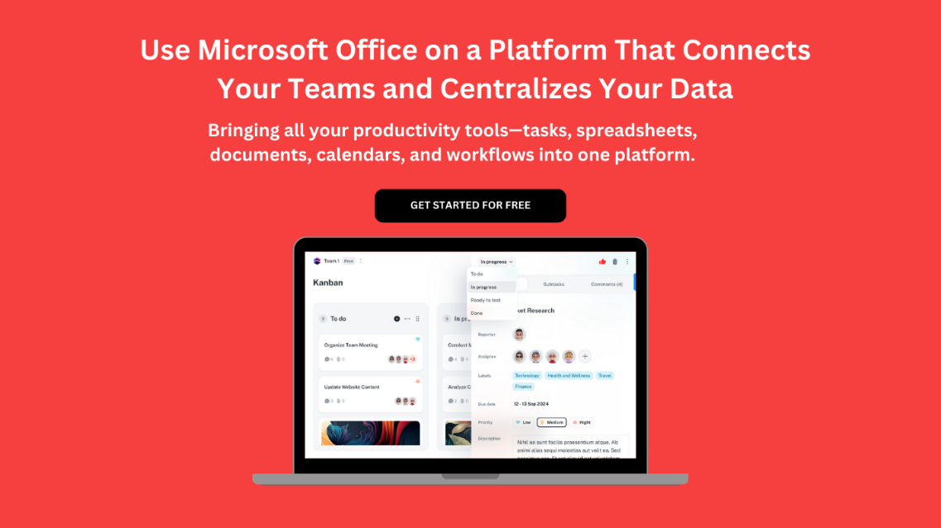](https://www.dimensionalrisk.com/)