**[](https://www.dimensionalrisk.com/)**

**Employee Engagement & Satisfaction Survey**

**Purpose:**This survey aims to gather insights about employee satisfaction, engagement, and the overall work environment to help the organization enhance workplace culture and improve retention.

**Job Satisfaction**

1. **How satisfied are you with your current job responsibilities?**  
   ☐ Very Dissatisfied  
   ☐ Dissatisfied  
   ☐ Neutral  
   ☐ Satisfied  
   ☐ Very Satisfied
2. **Do you feel your job is meaningful and impactful?**  
   ☐ Yes  
   ☐ No  
   ☐ Sometimes
3. **How would you rate your work-life balance?**  
   ☐ Very Poor  
   ☐ Poor  
   ☐ Neutral  
   ☐ Good  
   ☐ Excellent
4. **Do you feel your workload is manageable?**  
   ☐ Yes  
   ☐ No  
   ☐ Sometimes

**Manager and Team Relations**

1. **How would you rate your relationship with your direct manager?**  
   ☐ Very Poor  
   ☐ Poor  
   ☐ Neutral  
   ☐ Good  
   ☐ Excellent
2. **Do you receive regular feedback on your performance from your manager?**  
   ☐ Yes  
   ☐ No
3. **How satisfied are you with the level of support you receive from your team?**  
   ☐ Very Dissatisfied  
   ☐ Dissatisfied  
   ☐ Neutral  
   ☐ Satisfied  
   ☐ Very Satisfied

**Company Culture & Environment**

1. **How would you describe the company culture?**  
   ☐ Very Negative  
   ☐ Negative  
   ☐ Neutral  
   ☐ Positive  
   ☐ Very Positive
2. **Do you feel valued as an employee at this company?**  
   ☐ Yes  
   ☐ No  
   ☐ Sometimes
3. **Do you believe the company promotes diversity and inclusion?**  
   ☐ Yes  
   ☐ No  
   ☐ Not Sure

**Employee Recognition & Growth**

1. **Do you feel your contributions are recognized by your team and manager?**  
   ☐ Yes  
   ☐ No  
   ☐ Sometimes
2. **How satisfied are you with the career growth and development opportunities offered?**  
   ☐ Very Dissatisfied  
   ☐ Dissatisfied  
   ☐ Neutral  
   ☐ Satisfied  
   ☐ Very Satisfied
3. **Do you feel there is room for growth in your current role?**  
   ☐ Yes  
   ☐ No  
   ☐ Not Sure

**Overall Engagement**

1. **On a scale of 1-10, how likely are you to recommend working at this company to a friend or colleague?**  
   ☐ 1 (Not Likely)  
   ☐ 2  
   ☐ 3  
   ☐ 4  
   ☐ 5  
   ☐ 6  
   ☐ 7  
   ☐ 8  
   ☐ 9  
   ☐ 10 (Very Likely)
2. **What is the most important change that could improve your job satisfaction or overall work experience?**

Instructions for Completion:

1. This survey is for all employees to evaluate their engagement and satisfaction levels.
2. Please answer as honestly as possible. All responses are anonymous and will be used to improve the work environment.
3. The survey is designed to gather key insights that will help HR make data-driven decisions to improve employee satisfaction and retention.

Disclaimer:

Any articles, templates, or information provided by Dimensional Risk on the website are for reference only. While we strive to keep the information up to date and correct, we make no representations or warranties of any kind, express or implied, about the completeness, accuracy, reliability, suitability, or availability with respect to the website or the information, articles, templates, or related graphics contained on the website. Any reliance you place on such information is therefore strictly at your own risk.

[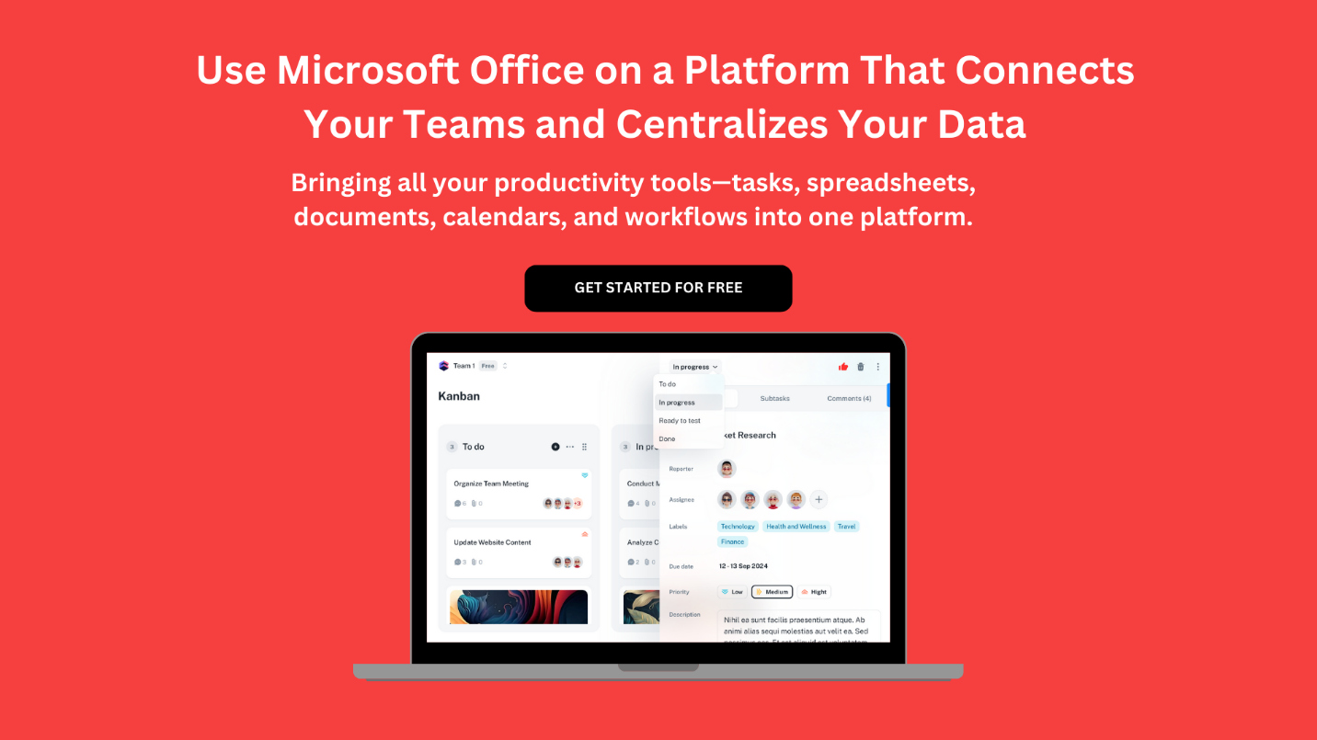](https://www.dimensionalrisk.com/)