**[](https://www.dimensionalrisk.com/)**

**Compliance & Policy Review Survey**

**Purpose:**

This survey assesses the effectiveness and adequacy of company policies, ensuring compliance with legal and regulatory requirements. It helps identify gaps and areas requiring updates or improvements.

**Policy Effectiveness**

1. **Do you believe the organization’s current policies are sufficient to ensure compliance with all relevant laws and regulations?  
   ☐** Strongly Disagree  
   ☐ Disagree  
   ☐ Neutral  
   ☐ Agree  
   ☐ Strongly Agree
2. **Are the organization’s policies regularly reviewed and updated to reflect changes in legal and regulatory requirements?  
   ☐** Yes  
   ☐ No  
   ☐ Not Sure
3. **How would you rate the clarity and accessibility of the company’s compliance policies?  
   ☐** Very Poor  
   ☐ Poor  
   ☐ Neutral  
   ☐ Good  
   ☐ Excellent

**Employee Awareness and Training**

1. **Do employees receive sufficient training to understand and adhere to compliance policies?  
   ☐** Yes  
   ☐ No  
   ☐ Somewhat
2. **How confident are you that employees across all departments understand their compliance responsibilities?  
   ☐** Not Confident  
   ☐ Slightly Confident  
   ☐ Neutral  
   ☐ Confident  
   ☐ Very Confident
3. **How often does the company conduct compliance training sessions?  
   ☐** Annually  
   ☐ Biannually  
   ☐ Quarterly  
   ☐ Rarely  
   ☐ Never

**Policy Gaps and Risks**

1. **Are there any areas of compliance where you feel the organization is at risk?**☐ Yes  
   ☐ No  
   If yes, please specify:
2. **Have there been any recent instances where company policies were not followed?**☐ Yes  
   ☐ No  
   **If yes, what was the outcome?**
3. **Do you feel there are any policies that need immediate attention or revision?**☐ Yes  
   ☐ No  
   **If yes, please describe:**

**Legal and Regulatory Updates**

1. **How effective is the organization at monitoring changes in laws and regulations relevant to the business?  
   ☐** Very Ineffective  
   ☐ Ineffective  
   ☐ Neutral  
   ☐ Effective  
   ☐ Very Effective
2. **Are updates to legal or regulatory requirements communicated clearly to all relevant teams?  
   ☐** Yes  
   ☐ No  
   ☐ Sometimes
3. **How confident are you that the company has processes in place to adapt quickly to legal or regulatory changes?  
   ☐** Not Confident  
   ☐ Slightly Confident  
   ☐ Neutral  
   ☐ Confident  
   ☐ Very Confident

**Future Improvements**

1. **What areas of compliance would benefit from additional resources or improvements**
2. **Are there specific policies you believe should be prioritized for review this year?**
3. **What additional steps could the organization take to strengthen compliance and policy enforcement?**

**Instructions for Completion:**

* This survey is intended for legal and compliance team members, managers, or department heads.
* Please provide detailed and honest feedback to help strengthen the organization’s compliance framework.
* Your responses will guide improvements in policies, training, and compliance processes.

Disclaimer:

Any articles, templates, or information provided by Dimensional Risk on the website are for reference only. While we strive to keep the information up to date and correct, we make no representations or warranties of any kind, express or implied, about the completeness, accuracy, reliability, suitability, or availability with respect to the website or the information, articles, templates, or related graphics contained on the website. Any reliance you place on such information is therefore strictly at your own risk.

[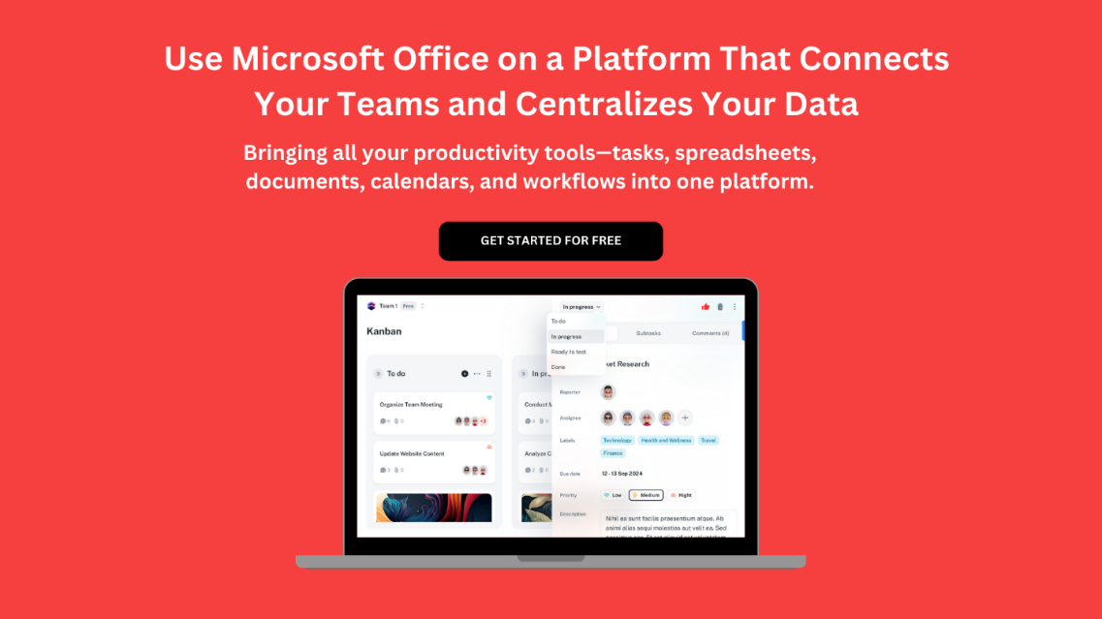](https://www.dimensionalrisk.com/)